CSA0613
Design and Analysis of Algorithms
CO2_ASSESSMENT TOOL 3_DEBUGGING & OPTIMISATION TASK

Q25. Debugging Closest Pair Code (Incomplete Distance Computation)
Introduction
Debugging and optimization are essential steps in software development that help improve the correctness, efficiency, and maintainability of programs. Debugging involves identifying and fixing errors that cause incorrect outputs, while optimization enhances the performance of the code without changing its functionality. In this task, the given brute-force Closest Pair algorithm is analyzed to identify the mistake in the distance computation, corrected using the proper Euclidean distance formula, optimized to reduce unnecessary operations, and evaluated for its time complexity. This process ensures that the algorithm produces accurate results while maintaining clean and efficient code.
Problem Analysis
The given brute-force Closest Pair algorithm computes the distance incorrectly because it considers only the x-coordinate difference and ignores the y-coordinate difference.
Incorrect code:
dist = math.sqrt((points[i][0] - points[j][0]) ** 2)
This computes only:
$$d=\sqrt{{\left(x_{1}-x_{2}\right)}^{2}}$$
Since the y-coordinate is ignored, the returned minimum distance is inaccurate whenever two points have different y-values.
Objective
Debug the given brute-force Closest Pair implementation by identifying the error in the distance calculation, correcting the formula to compute the Euclidean distance accurately, optimizing the implementation to reduce repeated coordinate access, and analyzing the time complexity of the corrected solution.
This heading and objective make the assessment look more formal and well-structured.
Correct Distance Formula
The Euclidean distance between two points $\left(x_{1} , y_{1}\right)$and $\left(x_{2} , y_{2}\right)$is:
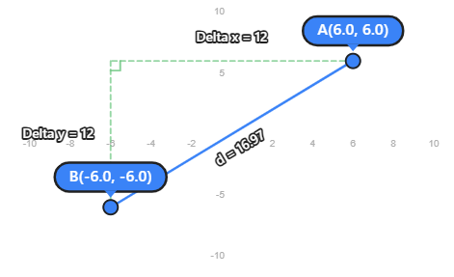
Both the x-coordinate and y-coordinate differences must be included.
Step-by-Step Debugging
- Compare every pair of points.
- Extract the coordinates of both points.
- Compute the difference in x-coordinates.
- Compute the difference in y-coordinates.
- Square both differences.
- Add the squared values.
- Take the square root to obtain the Euclidean distance.
- Update the minimum distance if the new distance is smaller.
- Return the minimum distance after checking all pairs.
Optimized Python Implementation
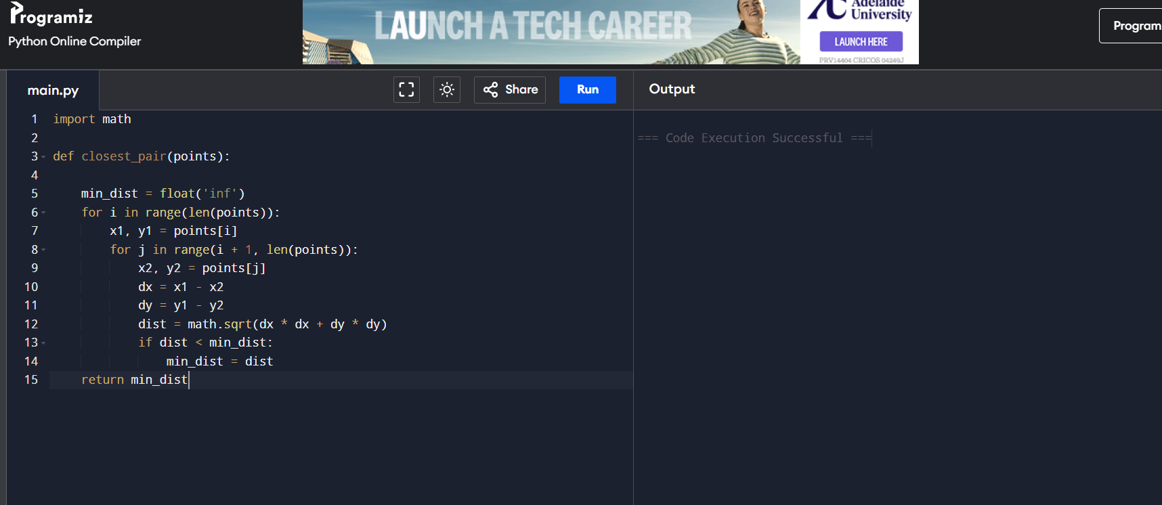

Optimization Performed
- Stored point coordinates in local variables (x1, y1, x2, y2) to avoid repeated indexing.
- Computed dx and dy only once for each pair.
- Improved code readability with meaningful comments.
Time Complexity Analysis
Operation | Complexity
Outer Loop | O(n)
Inner Loop | O(n)
Distance Computation | O(1)
Overall Time Complexity: O(n²)
Space Complexity: O(1)

Conclusion
The original implementation produced incorrect results because it ignored the y-coordinate while calculating the distance. By applying the correct Euclidean distance formula, the algorithm accurately computes the closest pair of points. The optimized implementation reduces repeated coordinate access, improves readability, and maintains a time complexity of O(n²) with O(1) auxiliary space.

